Emergency Shower Blue Eagle UK309
(Instruction Book)

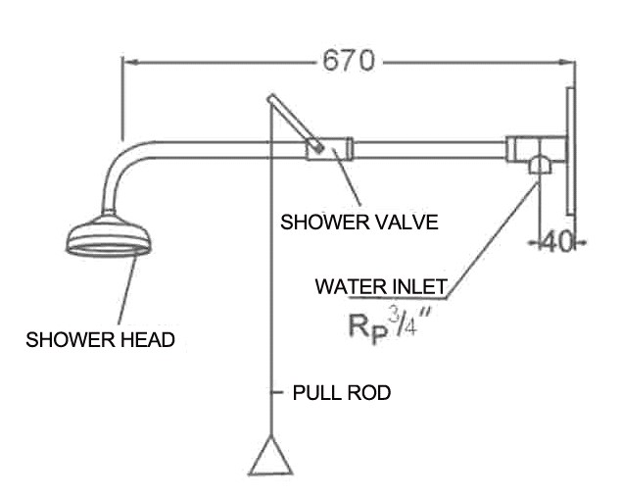

*Usage

This unit is not only the essential equipment of labor protection,but also the essential facilities against poisonous and corrosive material.If accidents happens,reduce the damage to the minimum degree by quickly spraying or washing the hurt.

*Main material

Good quality stainless steel, shower head is made of stainless steel.

*Structure features

Stainless steel ball valve switch, using conveniently, safety seal, use life is longer.
*Main function parameters

Pressure |  |  | Flux L/Min | Temperature
Nominal pressure | Seal pressure | Working pressure | Shower | Tepid water
0.4 | 0.45 | 0.20-0.40 | ≥75.5
Choosing these data is considering the hurt to the skin, eye(s), when accidents happen.

*Method of application

Downward pull switch to open (angle 90),push up swith to close.

*Packing list

No. | Part name | Quanlity
1 | Shower head | 1 PCS
2 | Shower switch handle | 1 PCS
3 | Stainless steel pipe | 1 PCS

